Overhead Stirrer R 100CT

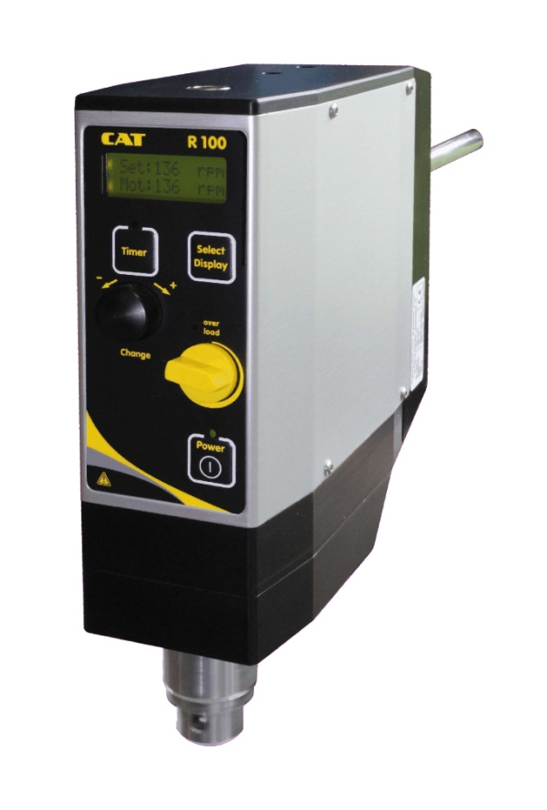 | The universal laboratory stirring motor for rheometric tests.  Powerful microprocessor controlled (fuzzy logic) stirrer for optimum performance and accuracy with a maximum torque of 600 Ncm, hollow shaft and precision chuck of 10.5 mm.  A multi-step safety system carries out a self test of all safety functions and detects and protects against overload as well as overtemperature.  The bright back-lit digital display shows all relevant system data (power input, power output and torque) plus simultaneous display of set and actual motor speed. The display also allows for readout of the absolute or relative torque measurements as well as the power output in watts at the shaft.  Speed range 10-500 rpm with soft start and soft stop logic.  Torque limits, maximum and minimum motor speeds are programmable.  The unit is supplied with an RS232-interface for computer control. There is also an analogue input for easy remote speed control and analogue output for recorder as well as a programmable switch-off timer.  The R100-series is designed for stirring medium and high viscous media.

Part No. | PN: 60314-00 230 V, 50 Hz  PN: 60314-01 115 V, 60 Hz
Power consumption | 300 W
Power output | Max. 220 watts shaft power output
Torque | Max. torque: 600 Ncm (20 min)  continuous torque (at 250 RPM): 400 Ncm  maximum limitation of torque (programmable)
Speed | 10 – 500 rpm
Chuck capacity | 1-10,5 mm
Analogue input | Allow or block speed setting via external analogue voltage control. (0-10V) programmable  Allows speed control via potentiometer
Analogue output | Analogue output (0-4V, programmable) for recording of process parameters (speed, torque, power)
LCD-Display | Bright back-lit LCD display, showing all relevant system data.  Simultaneous display of set and real values of motor speed, torque, or power output.
Incremental encoder wheel | allows fast and intuitive adjustment of timer and system settings
Timer function | Programmable switch-off timer, programmable from 1 minute to 99 days. Resolution: 1 minute
Torque output display | displays true torque at shaft in Ncm  (relative or absolute readout possible)  Accuracy: 5%
Power output display | Displays true power output at shaft in watts.  (relative or absolute readout possible)  Accuracy: 5%
Motor specification | - torque microprocessor controlled for easy operation and accuracy  - soft-start and soft-stop logic prevents splashing of liquid  - extra long life, high performance, brush motor  - silent belt drive power transmission
Multistep safety system | detects and protects against the following dangerous situations:  - rotor stuck/block detection  - motor overtemperature monitoring  - self test of all safety functions after switching on
Auxiliary functions | User programmable limits for:  maximum motor speed (10-500 rpm)  maximum allowed torque at shaft (10-600 Ncm)
RS232 interface | programmable baudrate: 1200,2400,4800; 8,N,1  Full remote access of all stirrer functions (read and write)  daisy chain feature by sub addressing allows connecting up to 255 units to only one serial interface on the computer side.  Windows® software optional available
Permissible ambient temperature | 5 - 40 °C within operating area, e.g. fume cupboard
Permissible humidity | 80 % RH
Safety class acc. to  DIN EN 60529 | IP42
Case dimensions | 78 x 200 x 250 mm (W x D x H)
weight | 5.5 Kg

Accessories and stirring tools (optional):
U-Stand Part No. 60494-00
Special Clamp to fix the unit to a stand Part No. 60495-00
Stirring shaft protector to be fixed to the stand Part No. 20618-60
„Jumbo“-Clamp to fix
the Stirring shaft protector to the stand Part No. 8B005650
RS 232 Interface cable D-Sub 9pin 1,8m Part No. 30275-51
USB to RS23 Adapter Part No. 30244-01
Software Stirrer Control Part No. (upon request)

