Overhead Stirrer R 80D-PC

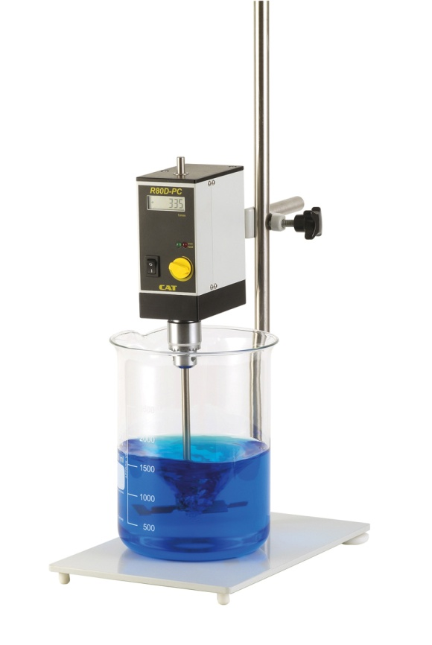 | Long lasting stirrer with electronic feed-back speed control and digital speed display.  This overhead stirrer is especially useful for applications where for a short time dynamic viscosity occurs but a still handy tool is requested.  The stirrer comes with RS232 interface for control via a PC.  The speed is steplessly adjustable from 20 to 700 rpm.  The maximum torque is 80 Ncm.  Speed is shown on the digital display.

Part No. | 60311-00 (230V)  63011-01 (115 V)
Stirring Volume (H₂O) | 120l
Motor | Permanently generated direct –current motor
Speed Range | 20 – 700 1/min
Nominal Rating | 120 Watt input  Short Term Overload 30%
Power output | 100 W
Torque over entire speed range | 80 Ncm
Capacity of Chuck | 0.5 – 10.5 mm
Viscosity of Medium | Average values (water to wallpaper paste)
Mains Voltage | 200 -250 V, 50/60 Hz or 115 V +/- 10%, 50/60 Hz
Permissible period of operation | 100%, Continuous operation may require service intervals
RS232 | yes
Admissible temp. of surrounding | + 5°C to 40°C
Diameter of support rod | 13 mm
Length of support rod | 196 mm
Weight | 2,5 kg
Dimensions | 65 x 200 (incl. 55 mm Chuck) x 120 mm (W x H x D)

Accessories and Stirring Paddles (optional)

Guard for agitator shaft Part no.: 20618-60
Pedestal Stand incl. rod Part no.: 60491-00
Cross over clamp Part no.: 60492-00
Cross over clamp made of steel Part no.: 60492-50
Blade stirring paddle Part no.: 8B009405
Centrifugal stirring paddle Part no.: 8B009211
Propeller stirring paddle Part no.: 8B009105
9 Pin SUB-D cable, 1.8 m long (Part no.: 30275-51)
USB-RS232 Adaptor (Part no.: 30244-01)

